DEVELOP A PYTHON SCRIPT

|  |  |
| --- | --- |
| TEAM ID | PNT2022TMID44628 |
| PROJECT NAME | IOT BASED SAFETY GADGET FOR CHILD SAFETY AND MONITORING SYSTEM |

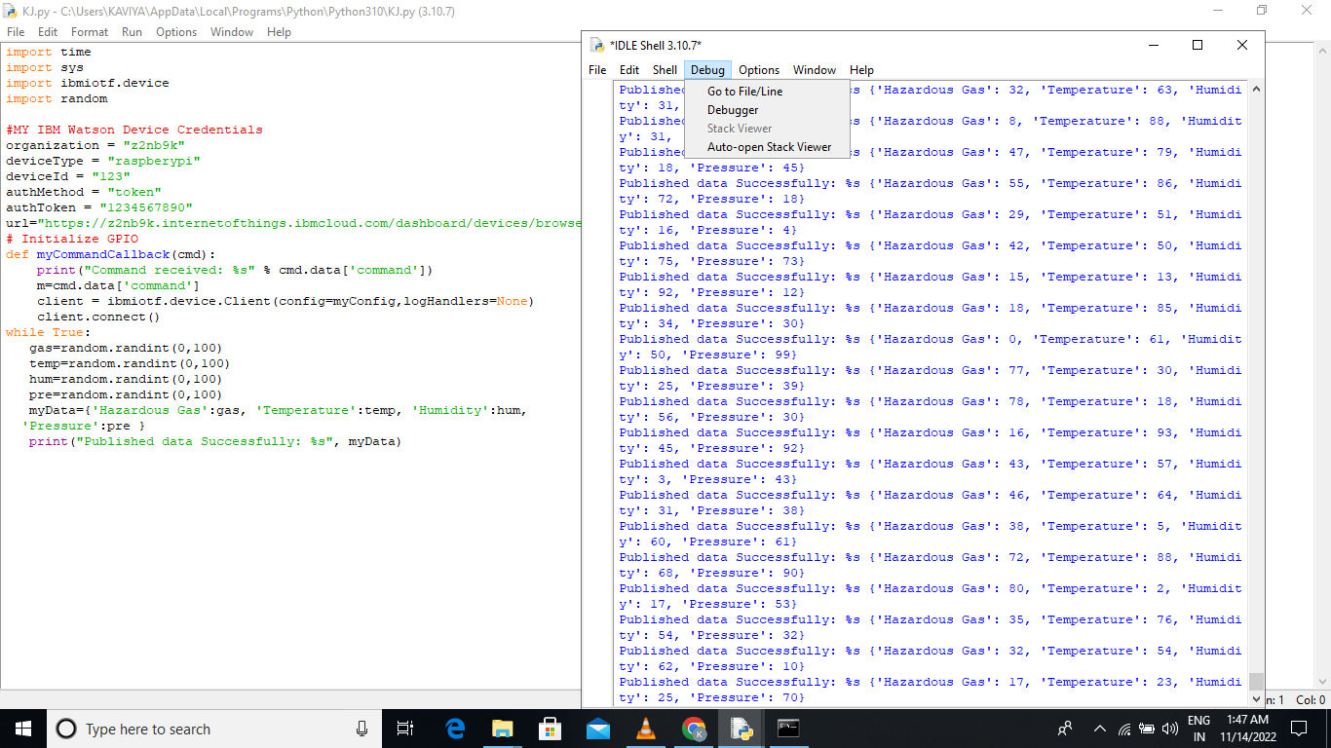

THE PYTHON IS DEVELOPED SUCCESSFULLY.